STEP 1:CREATE A FLOW CHART LIKE THESE
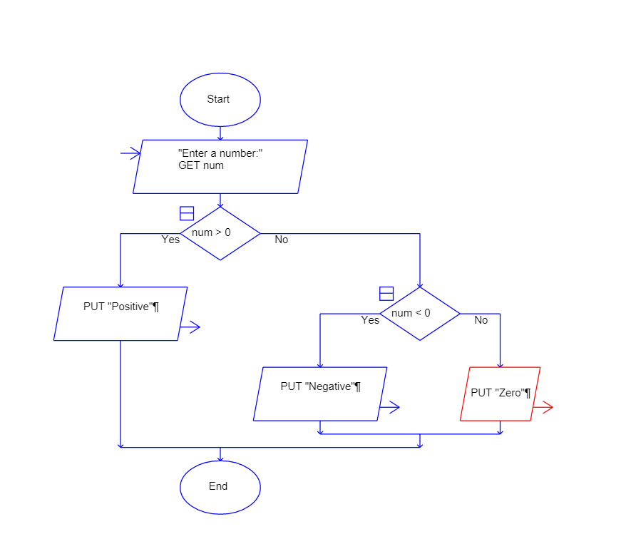

STEP 2: START THE SIMULATION BUTTON
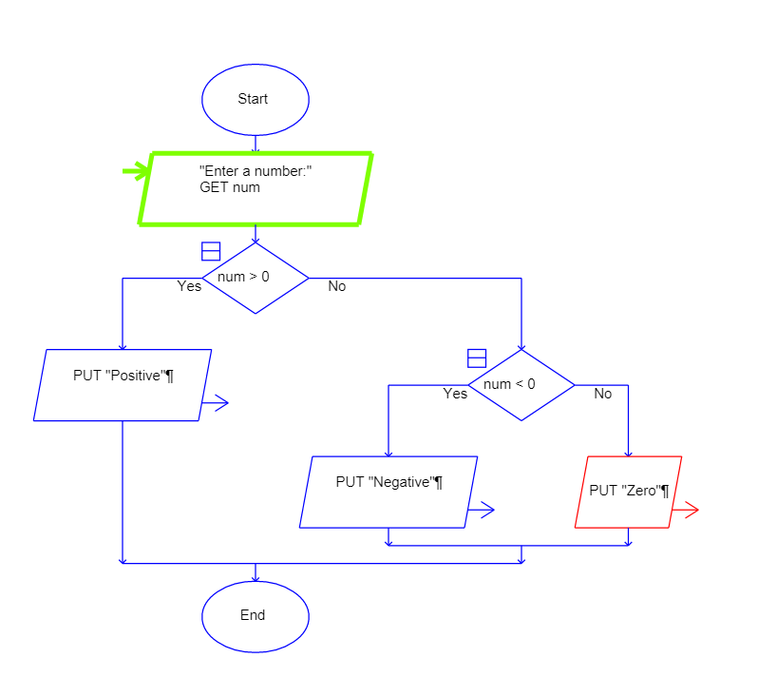

STEP 3: ENTER THE INPUT EXAMPLE -9
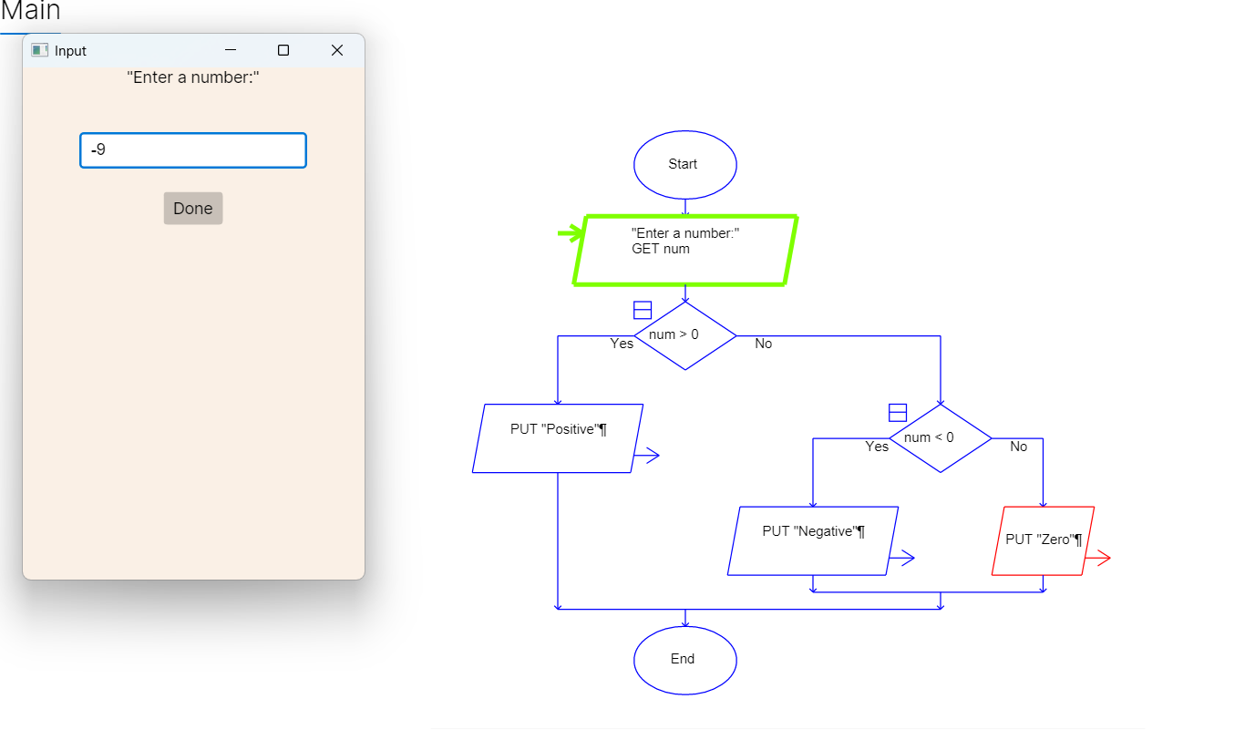
STEP 4:-EVALUATE THE OUTPUT


